CSE- 438 Assignement1 Screenshots
Submitted By: Roshan Raj Kanakaiprath
ASU ID:- 1222478062

Note: Because of my screen

Screenshot 1:(An enlarged section on Kernel Shark)

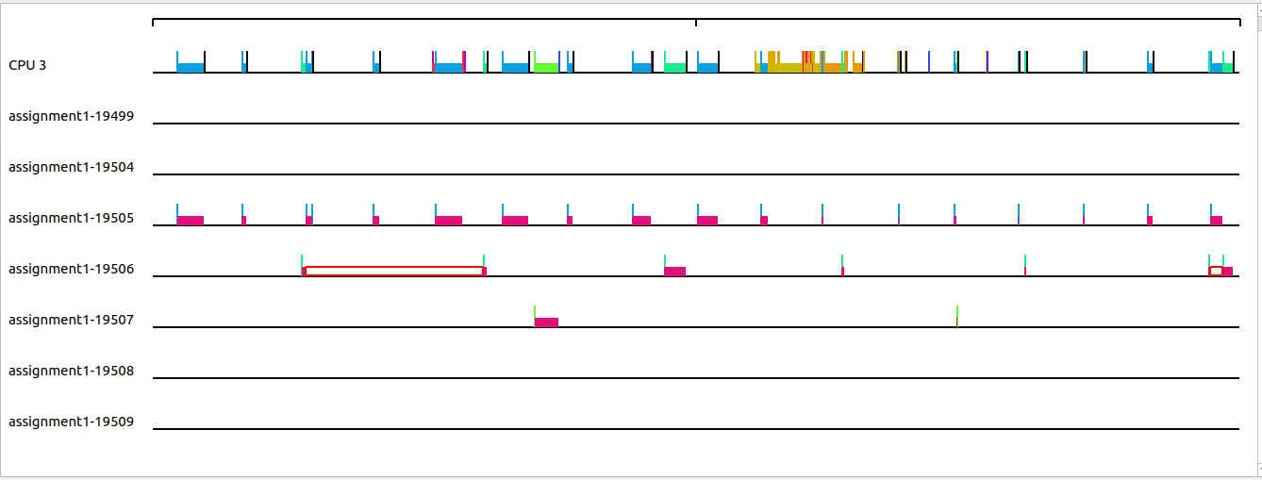
Screenshot 2: (The complete Kernel Shark recording)

